Unity of Pomona
Rev. Jan Chase, Minister
11:00 Sunday Celebration Service
November Bulletin 2023

(Please silence your electronic devices during the service)

Welcome & Greetings

Prayer & Lord’s Prayer Rev. Jan Chase

Announcements Rev. Jan & Others

Offering/Donation Blessing:
“Divine Love through me, blesses and multiplies
All I am, all I give, all I do and All that I receive.”

Daily Word Darlene Hargrove & Others

November Lessons: Building the Beloved Community. Rev. Jan is helping with a class at the University of La Verne entitled “Building the Beloved Community” with Rev. Dr. Richard Rose.
We are studying Native American perspectives, Gandhi’s politics, Howard Thurman and Martin Luther King, Jr. There are many layers to this work, and in Unity, as always, we begin within and build out.

11/5 “Would you Rather be Right or Happy?” - Rev. Jan Chase
11/12 “Trusting Your Authentic Self” - Rev. Jan Chase
11/19 “Gratitude as State of Being.” with Rev. Drak Druella
11/26 “What to do with Painful Truths -with Phillip Senteno

Closing Circle/ Prayer of Protection//Peace
The Light of God surrounds us. The Love of God enfolds us.
The Power of God protects us. The Presence of God watches over us. Wherever we are, God is. And All is Well.

We welcome our guest speakers.
Rev. Drakar Druella is a Science of Mind minister & hospice chaplain, who brings music as well as New Thought Messages.
Phillip Senteno- Co President of our Unity of Pomona Board who brings a Native American perspective to us
How Blessed We Are!

Music & Poetry to Remind Us

Beautiful City lyrics from Godspell

Come sing me sweet rejoicing- Come sing me love
We're not afraid of voicing- All the things We're dreaming of
Oh, high and low, And everywhere we go
We can build A beautiful city, Yes we can, Oh yes we can
We can build, A beautiful city, Call it out, And call it the city of man.
We don't need alabaster, We don't need chrome,
We've got our special plaster, Take my hand I'll take you home
We see nations rise, In each other's eyes
We can build A beautiful city -Yes we can, Oh yes we can
We can build A beautiful city Call it out, And call it the city of man
Come sing me sweet rejoicing, Come sing me love
We're not afraid of voicing, All the things We're dreaming of
Oh, high and low, And everywhere we go - We can build A beautiful city
Yes we can, Oh yes we can, We can build A beautiful city Call it out
And call it the city of man Last
2013
Blessing To The World by Karen Drucker
You are the heart, You are the hands.
You are the voice of Spirit on earth. And who you are, and all you do, is a blessing to the world.

What Is Mine to Give? by Karen Drucker
What is mine to give? What is mine to do?
All I want is to share myself with you.
So I stand here asking what can I do?
What is mine to give? I give it to you.

The Grace Prayer
Into Thy hands I commit my spirit. Thy will is my will, heal me at depth, so that I may glorify God.
Reveal that which needs to be revealed, Heal that which needs to be healed, so that I may glorify God.

Thank You for your generosity!
Because of you, we can do our work! Check out our Facebook & Website www.UnityofPomona.org https://www.unityofpomona.org/about-us
Digital Donations are also accepted on our “Network for Good” DONATE BUTTON on our Sunday Lessons on my Jan Chase Facebook History & Timeline https://www.facebook.com/jan.chase.52
and on our UnityChurchofPomona Facebook Page www.facebook.com/Unity-Church-of-Pomona

Information
We are grateful for Robert Wilkiewicz, Angel Arellano and Andy Quinones our technical producers, for Jacqi Morrison and other Worship Assistants, for Jacqi Morrison, Jennifer Derry, Regina Reynolds and Lee Ernst for coordinating our meals and for all who support us in many ways!

Sunday Food & Fellowship after our Service: Our Sunday Potlucks are back. Feel free to join us for food after our service and to bring food to share. Thanks. Donations go for our paper supplies.

We celebrate with all who have November Birthdays!
Compassionate Pomona theme for November: Gratitude

DAILY WORD November 2023
11/5 Transitions: I flow with life’s changes.
11/12 Faith: Faith heals, prospers, blesses, and sustains me.
11/19 Guidance: Divine guidance clears and lights my way.
11/26 Grace: I trust grace is my constant blessing.

Unity focuses on one of our 12 Powers each month.
In November we focus on the faculty of Elimination:
The ability to release, deny, remove, denounce, let go. The disciple Thaddeus, represents the expulsion of negative thinking. The corresponding color is russet and the location is the abdominal region. Affirmation: I release anything and everything that no longer serves my unfolding good.

2023: Opening to this Adventure Called LIFE
As we awaken to the truth of our being, we begin to realize that life is a great adventure, filled with experiences that can bring us great joy, when we bring curiosity, nonresistance, willingness, and acceptance into each situation. It dawns on us that we no longer need to fight life because Life is another name for God, and is always there blessing us and calling us into the growth our souls call us to learn. As I open to allow Spirit to guide me and as I look with spiritual eyes, I find my life is filled with marvelous miracles.
NOVEMBER 2023 CLASSES/ EVENTS

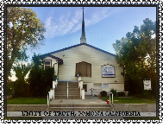
Our Sunday Lessons are live-streamed each week at 11 am PDT on Facebook through Jan Chase’s Time-Line and can be found and viewed later via her history. We are also gathering in person. Please join us in the way that works best for you. We hope you will share these timely lessons that help us understand ourselves, our needs, and others in this time of change. Please DONATE. Thank you for your tithes & gifts.

Mondays 5 – 6 pm: Book Study via Zoom with Jan Chase. The Forty Rules of Love: A Novel of Rumi by Elif Shafak Zoom https://us02web.zoom.us/j/8282536942

Wed. 6:30 -7:30 pm Meditation/Prayer/Check-In on Zoom Meeting ID: 828 253 6942 (Join Zoom: https://us02web.zoom.us/j/828253694Unity2
One tap mobile: +16699009128,,8282536942# US
Dial by your location: +1 669 900 9128 US (San Jose)

Compassionate Pomona Meetings on Zoom The 1st Thursday at 9:45-11:30 am PST & 3rd Thursday at 10 am PST.To join the Zoom Meetings click or copy/paste this link: https://us02web.zoom.us/j/87534833472 ID: 875 3483 3472
Conversations with the Pomona Police: Tues11/14/23 at 11 am.
Ask Renee Barbee reneebarbee7@gmail.com for zoom link

Sun. Nov. 12, 1:15 – 4:15: Unity 102 Class for Information about and/or to Join Unity of Pomona.

Fri. Nov. 17, 1 pm: Lunch Out at Denny’s, 548 W Arrow Hwy, San Dimas.

Sun. Nov. 19, noon: Thanksgiving Dinner Together

Sun. Nov. 19, 1:30 pm: Short Unity Board Meeting.

Sun. Nov. 19, 5-6:30 pm. Soul Connection

DATES FOR OTHER COMMUNITY EVENTS
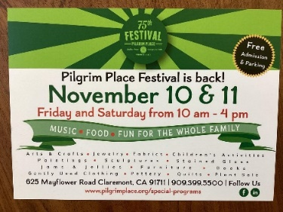
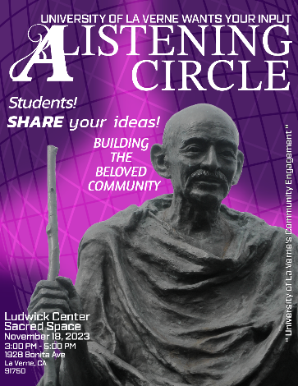
Wed., Nov 15, 6 to 8 p.m. “Prosperity in the Pomona Valley: Paving the Path to a Wellbeing Economy” at Palomares Community Center, 499 E. Arrow Hwy., Pomona 91767. Free pizza.
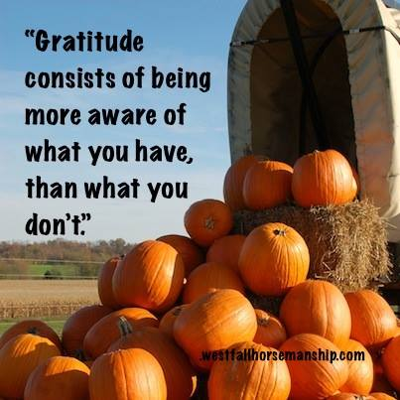
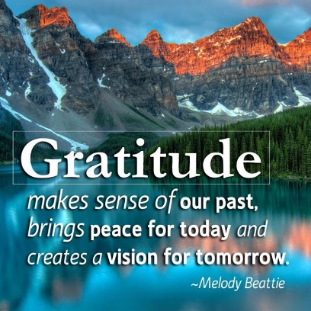

SERVING US AT UNITY OF POMONA
MINISTER: Rev. Jan Chase
BOARD MEMBERS: Jacqi Morrison & Phillip Senteno co-Presidents, Rev. Jan Chase, Jennifer Derry, Sharen Whitaker,
Advisory Board Members: Linda Lowry & Andrew Quinones, Lee Ernst
BUILDING & GROUNDS: Phillip Senteno, Jacqi Morrison, Andrew Quinones, Robert Wilkiewicz
COUNTERS: Sharen Whitaker, Treas.; Jacqi Morrison, Jan Chase.
FELLOWSHIP: Lee Ernst, Regina Reynolds, Robert Wilkiewicz, Jacqi Morrison, All of us!
FUNDRAISING: Our Board & Congregation & Robert Wilkiewicz
GREETERS: Lee Ernst
MARKETING & MULTIMEDIA: Jan Chase, Jennifer Derry, Andrew Quinones
OFFICE SUPPORT: Jacqi Morrison, Linda Lowry, Jan Chase
POWER POINT OPERATOR: Robert Wilkiewicz Andrew Quinones,
SANCTUARY PREPARATION: Jacqi Morrison, Jan Chase,
SOUND SYSTEM: Jacqi Morrison, Robert Wilkiewicz, Angel Arellano
TECHNICAL SUPPORT: Andrew Quinones, Robert Wilkiewicz, Angel Arellano.
WORSHIP ASSISTANT: Jacqi Morrison, Darlene Hargrove
UNITY OF POMONA
A “New Thought” Interfaith Community
Promoting Peace & Understanding through Spiritual Practices, Study & Service and the “Golden Rule” of all our Faiths.

.“Centered in God, We Co-Create A World that Works for All.”

Open & Affirming. Welcoming People of All Faiths
(Our sanctuary art is an expression of
the religious diversity welcomed here.)

Sunday Celebration Service: 11:00 am
Live-streamed and recorded on Jan Chase’s FB & saved on Unity of Pomona’s FB

Church Contact Information:
524 E. Pasadena St. Pomona, CA 91767

Rev. Jan Chase: Cell: 909-896-0991
Email: -

Website: https://www.unityofpomona.org/
Facebook: Unity Church of Pomona

Church Office Hours:
Friday Afternoons & by Appointment
Call Jan at 909-896-0991 to schedule Appointments

Silent Unity Prayer Line: 1-816-969-2000
& Prayer Email: unity.org/prayer

NOVEMBER 2023 AFFIRMATIONS
Harmony: My every thought is in harmony with divine love.
Health: God is the health in every cell and system of my body.
Strength: My mind is steady, unwavering in spiritual strength.
Guidance: In every matter, I am guided by infinite intelligence. Peace: I am a radiating center of spiritual peace and confident living.

