Unity of Pomona
Rev. Jan Chase, Minister
11:00 Sunday Celebration Service
July Bulletin 2022

(Please silence your electronic devices during the service)

Welcome & Greetings
Opening Song “May the Blessings of God Rest Upon You” (WOS ) All

Prayer & Lord’s Prayer Rev. Jan Chase

Announcements Rev. Jan & Others

Offering/Donation Blessing:
“Divine Love through me, blesses and multiplies
All I am, all I give, all I do and All that I receive.”

Daily Word Jacqi Morrison & Others

July Lessons: This month’s lessons focus on ways to understand life from different perspectives, making navigating the perceived good, bad, and ugly easier.

7/3 “Freedom: Unlocking the Jail Cells of our Hearts”
Rev. Marianne Cordova Breen
7/10 “Lessons from my Family Vacation in Great
Britain.” Rev. Jan Chase
7/17 “The Gifts of COVID” Rev. Jan Chase
7/24 “Understanding the Blessings of Diversity” Rev. Jan Chase
7/31 “Working to Accept our Oneness with Life”
Rev. Jan Chase
Closing Circle/ Prayer of Protection//Peace
The Light of God surrounds us.
The Love of God enfolds us.
The Power of God protects us.
The Presence of God watches over us.
Wherever we are, God is. And All is Well.
Music to Remind Us.

May the Blessing of God Rest upon You
(Wings of Song 174)

May the blessing of God rest upon you,
May God’s peace abide with you,
May God’s presence illuminate your heart,
Now and forevermore.

How Could Anyone Ever Tell You
(By Karen Drucker in Songs of the Spirit Songbook)

How Could Anyone Ever Tell You
You were anything less than beautiful?
How could anyone every tell you, you were less than whole?
How could anyone fail to notice,
that your loving is a miracle,
How deeply you’re connected to my soul.

The Face of God
(by Karen Drucker in Chants & Sing-A-Longs)

You are the face of God, I hold you in my heart.
You are a part of me. You are the face of God.

You are the face of love, I hold you in my heart.
You are my family, You are the face of love.

Thank You for your generosity!
Because of you, we can do our work! Check out our New Website www.UnityofPomona.org set up by Andrew
https://www.unityofpomona.org/about-us
We are Happy to Receive as well as to Give!
Digital Donations are also accepted on our “Network for Good” DONATE BUTTON on our Sunday Lessons on my Jan Chase Facebook History & Timeline https://www.facebook.com/jan.chase.52
and on our UnityChurchofPomona Facebook Page www.facebook.com/Unity-Church-of-Pomona

Information

We are grateful for Robert Wilkiewicz our technical producer, for Jacqi Morrison our Worship Assistant, and for all who support us in many ways!

Sunday Food & Fellowship after our Service: Our Sunday Potlucks are back. Feel free to join us for food after our service and to bring food to share. Donations go for our paper supplies. Thanks.

We celebrate with all who have July Birthdays!

Compassionate Pomona July focus on Joy & Compassion

DAILY WORD
7/3 Free: Living from my Christ nature sets me free.
7/10 Generous: As I give, I share God’s abundance.
7/17 Trust: I place my trust in God.
7/24 Loving: I am a loving, caring presence.
7/31 Let God, Let God: I bless myself when I let go and let God.

Unity focuses on one of our 12 Powers each month. In July we focus on the faculty of Understanding—The ability to know, perceive, comprehend and apprehend. The corresponding color is gold and the location is the front of the brain. The disciple is Thomas. He represents the ability to see beyond appearances to reality. Affirmation: The light of understanding enables me to see clearly and to take right action.

2022: Journey of Awakening to the Truth of Our Being

As Spiritual Beings having an Earthly experience, we can learn to control and expand our mind to gain deeper understanding about ourselves, our relationship to Mother Earth and All our Relations.
This year we are looking at our Journey of Awakening to the Truth of our Being and the way Acts of Kindness improve our health, our relationships, and lift up our community. We will also continue to learn from the wisdom of many religious traditions and incorporate various spiritual practices into our services.

JULY 2022 CLASSES/ EVENTS

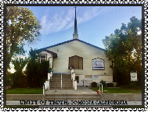
Our Sunday Lessons are live-streamed each week at 11 am PDT on Facebook through Jan Chase’s Time-Line and can be found and viewed later via her history. We are also gathering in person. Please join us in the way that works best for you. We hope you will share these timely lessons that help us understand ourselves, our needs, and others in this time of change. Please DONATE. Thank you for your tithes & gifts.

Mondays 5 – 6 pm: Book Study via Zoom with Jan Chase. Belonging to Life: The Journey of Awakening by Mary O’Malley. Zoom https://us02web.zoom.us/j/8282536942

Wed. 6:30 -7:30 pm Meditation/Prayer/Check-In on Zoom Meeting ID: 828 253 6942 (Due to Jan’s vacation only on Wed. June 1, 3 pm & Thurs. June 9, 3 pm then back on Wed. July 6 at 6:30 pm) Join Zoom: https://us02web.zoom.us/j/8282536942
One tap mobile: +16699009128,,8282536942# US
Dial by your location: +1 669 900 9128 US (San Jose)

Sun. July 10, 1:15 pm: Spiritual Alchemy- Transforming the Negative into the Positive. Join us!

The 1st Thursday at 9:45-11:30 am PST & 3rd Thursdays 10-11am Compassionate Pomona Meetings on Zoom
In July we will meet July 7 and July 21. To join the Zoom Meeting click or copy/paste this link:
https://us02web.zoom.us/j/87534833472 ID: 875 3483 3472
Conversations with the Pomona Police: Tues. 7/12/22 11 am.
Ask Renee Barbee reneebarbee7@gmail.com for zoom link.

Thurs, July 14, 1-2:30 pm: Lunch Out at Red Lobster, 9345 Monte Vista, Montclair, CA 91763

Sun. July 17, 5-6:30 pm: Soul Connections via Zoom Meeting ID: 231 352 7383; Passcode: soulconnec

Sun. July 17, 1:15 -3:30 pm: Next Unity Board Meeting
Zoom https://u1s02web.zoom.us/j/8282536942

Tues July 19, 1-2:20 pm: Unity SW Region Lunch at Unity of the Way, Vista, CA

DATES FOR OTHER COMMUNITY EVENTS

Thurs. July 14, 7-8:30 pm: NAACP Stakeholders’ Meeting, Zoom ID 764 9855 298

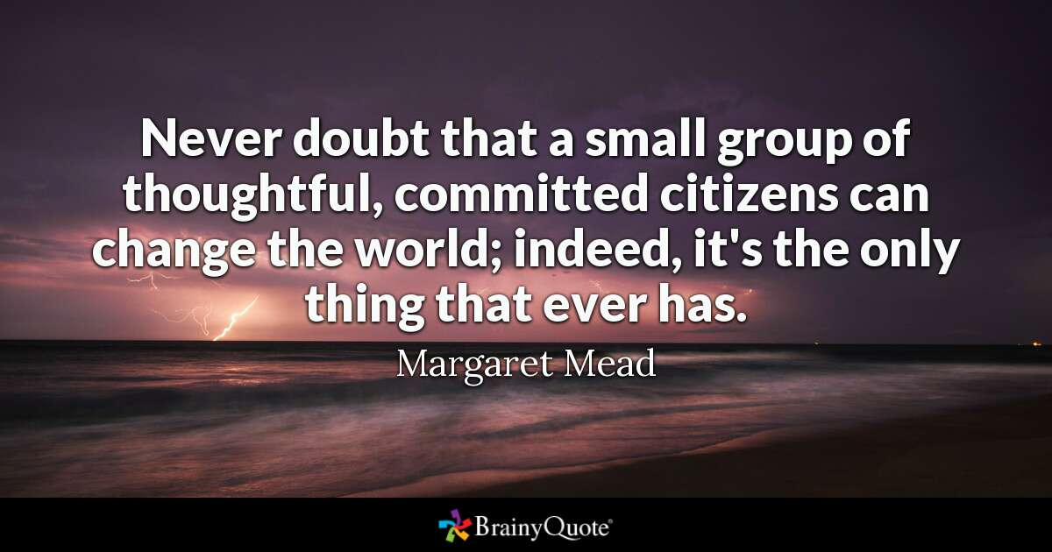

SERVING US AT UNITY OF POMONA
MINISTER: Rev. Jan Chase

BOARD MEMBERS: Jacqi Morrison & Phillip Senteno co-Presidents, Rev. Jan Chase, Jennifer Derry, Sharen Whitaker,
Advisory Board Members: Linda Lowry & Andrew Quinones

BUILDING & GROUNDS: Phillip Senteno, Jacqi Morrison, Andrew Quinones, Robert Wilkiewicz

MUSIC: Liz Irons, Jennifer Derry, Angela Robertson

COUNTERS: Sharen Whitaker, Treas.; Jacqi Morrison.

FELLOWSHIP: Darin Sizemore, Jacqi Morrison, Sharen Whitaker, Robert Wilkiewicz, Angela Robertson, All of us!
FUNDRAISING: Our Board & Congregation & Robert Wilkiewicz

MARKETING & MULTIMEDIA: Jan Chase, Jennifer Derry, Andrew Quinones

OFFICE SUPPORT: Sharen Whitaker Office Manager, Jacqi Morrison, Linda Lowry, Jan Chase

POWER POINT OPERATOR: Jan Chase, Andrew Quinones, Robert Wilkiewicz

SANCTUARY PREPARATION: Jacqi Morrison, Jan Chase

SOUND SYSTEM: Jacqi Morrison, Robert Wilkiewicz

TECHNICAL SUPPORT: Andrew Quinones, Robert Wilkiewicz

WORSHIP ASSISTANTS: Jacqi Morrison
UNITY OF POMONA
A “New Thought” Interfaith Community
Promoting Peace & Understanding through Spiritual Practices, Study & Service and the “Golden Rule” of all our Faiths.

.“Centered in God, We Co-Create A World that Works for All.”

Open & Affirming. Welcoming People of All Faiths
(Our sanctuary art is an expression of
the religious diversity welcomed here.)

Sunday Celebration Service: 11:00 am
Live-streamed and recorded on Jan Chase’s FB & saved on Unity of Pomona’s FB

Church Contact Information:
524 E. Pasadena St. Pomona, CA 91767
Office: 909-629-3035
Rev. Jan Chase: Hm: 909-596-4187, Cell: 909-896-0991
Email: Janhoshin@aol.com
Silent Unity Prayer Line: 1-816-969-2000
& Prayer Email: unity.org/prayer
Website: https://www.unityofpomona.org/
Facebook: Unity Church of Pomona

Church Office Hours:
Friday Afternoons & by Appointment
Call Jan at 909-596-4187 to schedule Appointments

JULY 2022 AFFIRMATIONS
Inner Peace: I relax into stillness and peace.
Healing: I thrive in the healing stream of divine life.
Strength: God is my strength; therefore, I am strong.
Prosperity: Centered in God, my hopes and dreams blossom. God is my good. I live in gratitude.
World Peace: I live in the harmony of divine love.

