Unity of Pomona
Rev. Jan Chase, Minister
11:00 Sunday Celebration Service
March Bulletin 2023

(Please silence your electronic devices during the service)

Welcome & Greetings
4
Prayer & Lord’s Prayer Rev. Jan Chase

Announcements Rev. Jan & Others

Offering/Donation Blessing:
“Divine Love through me, blesses and multiplies
All I am, all I give, all I do and All that I receive.”

Daily Word Darlene Hargrove & Others

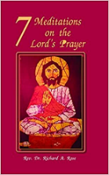
March Lessons: During this month of Lent we build a path to Christ Consciousness by moving up through our Chakra Energy Centers. by exploring the Lord’s Prayer. Who would have guessed that the Lord’s Prayer would hold the keys to unlocking our chakra centers, allowing us to open more and more to our own divinity and to Christ Consciousness. Much in these lessons have been inspired by the book 7 Meditations on the Lord’s Prayer by my Interfaith friend Rev. Dr. Richard Rose, Dept head of Theology at University of La Verne and an AME minister in Artesia.
3/05 “Thy Kingdom come…..Opening the Svadhisthana, 2nd or Sacral Chakra.” - Rev. Jan Chase
3/12 “Give us this day…..Opening the Manipura, 3rd or
Solar Plexus Chakra.” - Rev. Jan Chase
3/19 “And forgive us our trespasses…Opening the
Anahata , 4th or Heart Charka” Rev. Drakar Druella
3/26 “And lead us not into temptation….Opening the
Vishuddha, 5th or Throat Chakra” – Rev. Jan Chase

Closing Circle/ Prayer of Protection//Peace
The Light of God surrounds us.
The Love of God enfolds us.
The Power of God protects us.
The Presence of God watches over us.
Wherever we are, God is. And All is Well.
Music to Remind Us.
Let Your Light So Shine (Dances of Universal Peace III p 35)
Let your light so shine before all men. (X2)
That all my see your good works. (X2)
And glorify your father in heaven. (X2)
Halleluia, Halleluia, ((X2)

I Am Walking As the Light (Wings of Song 331)
I am walking as the light, as the light, as the light.
I am walking as the light, as the light of God.
As the light, as the light, as the light, as the light,
As the light, As the light, As the light of God.

Oh my good is everywhere, everywhere, everywhere.
Oh, my good is everywhere, manifesting now.
Over her, over there, Within, without, everywhere.
Thank You, God, for my good, manifesting now.

In Christ There Is No Eat or West (WOS 58)

In Christ there is no East or West, In Christ no south or north.

But one great fellowship of love throughout the whole wide earth.

This Little Light Of Mine

1 This little light of mine, I'm gonna let it shine.(X3)
Let it shine, let it shine, oh let it shine.

2 Ev'rywhere I go, I'm gonna let it shine. (X3)
Let it shine, let it shine, oh let it shine.

We welcome Rev. Drakar Druella, our guest minister.
Drak is a Science of Mind minister and chaplain, who brings music as well as New Thought and Interfaith Messages.

Thank You for your generosity!
Because of you, we can do our work! Check out our Facebook & Website www.UnityofPomona.org https://www.unityofpomona.org/about-us
Digital Donations are also accepted on our “Network for Good” DONATE BUTTON on our Sunday Lessons on my Jan Chase Facebook History & Timeline https://www.facebook.com/jan.chase.52
and on our UnityChurchofPomona Facebook Page www.facebook.com/Unity-Church-of-Pomona

Information

We are grateful for Robert Wilkiewicz and Andy Quinones our technical producers, for Jacqi Morrison our Worship Assistant, and for all who support us in many ways!

Sunday Food & Fellowship after our Service: Our Sunday Potlucks are back. Feel free to join us for food after our
service and to bring food to share. Donations go for our
paper supplies. Thanks.

We celebrate with all who have March Birthdays!
Compassionate Pomona March: Kindness & Service

DAILY WORD March 2023
3/5 Dominion: I claim dominion and direct the course of my life.
3/12 Illuminate: I welcome the light.
3/19 Comfort: I find comfort in expressions of love.
3/26 Joy: I draw from my wellspring of joy.

Unity focuses on one of our 12 powers each month.
In March we focus on WISDOM. The ability to evaluate, discern & apply what is known. The disciple that represents wisdom is James, son of Zebedee, the corresponding color is yellow and the location is the pit of the stomach.
Affirmation: I am guided by divine wisdom in every thought, word and action.

2023: Opening to this Adventure Called LIFE

As we awaken to the truth of our being, we begin to realize that life is a great adventure, filled with experiences that can bring us great joy, when we bring curiosity, nonresistance, willingness, and acceptance into each situation. It dawns on us that we no longer need to fight life because Life is another name for God, and is always there blessing us and calling us into the growth our souls call us to learn.
As I open to allow Spirit to guide me and as I look with spiritual eyes, I find my life is filled with marvelous miracles.

MARCH 2023 CLASSES/ EVENTS

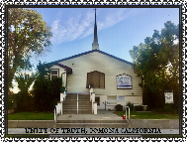
Our Sunday Lessons are live-streamed each week at 11 am PDT on Facebook through Jan Chase’s Time-Line and can be found and viewed later via her history. We are also gathering in person. Please join us in the way that works best for you. We hope you will share these timely lessons that help us understand ourselves, our needs, and others in this time of change. Please DONATE. Thank you for your tithes & gifts.

Mondays 5 – 6 pm: Book Study via Zoom with Jan Chase. Belonging to Life: The Journey of Awakening by Mary O’Malley. Zoom https://us02web.zoom.us/j/8282536942

Wed. 6:30 -7:30 pm Meditation/Prayer/Check-In on Zoom Meeting ID: 828 253 6942 (Join Zoom: https://us02web.zoom.us/j/828253694Unity2
One tap mobile: +16699009128,,8282536942# US
Dial by your location: +1 669 900 9128 US (San Jose)

Compassionate Pomona Meetings on Zoom The 1st Thursday at 9:45-11:30 am PST & 3rd Thursday at 10 am PST.To join the Zoom Meetings click or copy/paste this link: https://us02web.zoom.us/j/87534833472 ID: 875 3483 3472
Conversations with the Pomona Police: Tues. 3/14/23 at 11 am.
Ask Renee Barbee reneebarbee7@gmail.com for zoom link.

Sun. March 19, 5-6:30 pm: Hybrid Soul Connections in-person at Unity of Pomona and on zoom:

Sun. March 26, 1:15- 3:30: Unity Board Meeting.

DATES FOR OTHER COMMUNITY EVENTS

Chakra Meditation on Universal Healing: Awakening the Heart of Humanity Series which the Charter RISE Team created for the World Interfaith Harmony Week at the beginning of February..https://charterforcompassion.org/programs/world-: ISinterfaith-harmony-week-2023

The Lord’s Prayer
Our Father, Which art in Heaven, Hallowed be thy Name. Thy Kingdom come, Thy will be done in earth
As it is in Heaven.
Give us this day our daily bread.
And forgive us our trespasses,
As we forgive them that trespass against us.
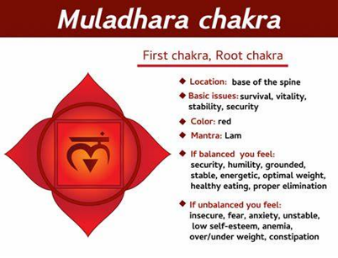
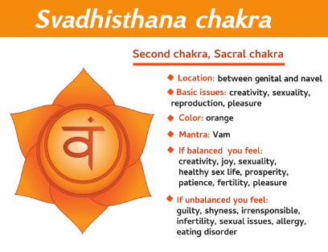
And lead us not into temptation, But deliver us from evil. For thine is the kingdom, the power, and the glory, For ever and ever. Amen
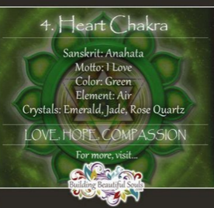

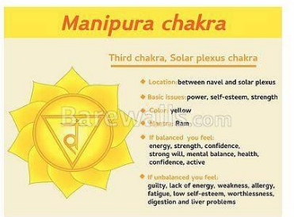
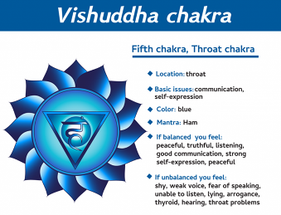

Next Month we work with the Third Eye and Crown Chakras

SERVING US AT UNITY OF POMONA
MINISTER: Rev. Jan Chase
BOARD MEMBERS: Jacqi Morrison & Phillip Senteno co-Presidents, Rev. Jan Chase, Jennifer Derry, Sharen Whitaker,
Advisory Board Members: Linda Lowry & Andrew Quinones
BUILDING & GROUNDS: Phillip Senteno, Jacqi Morrison, Andrew Quinones, Robert Wilkiewicz
COUNTERS: Sharen Whitaker, Treas.; Jacqi Morrison, Jan Chase.
FELLOWSHIP: , Angela Robertson, Sharen Whitaker, Robert Wilkiewicz, Jacqi Morrison, All of us!
FUNDRAISING: Our Board & Congregation & Robert Wilkiewicz
MARKETING & MULTIMEDIA: Jan Chase, Jennifer Derry, Andrew Quinones
OFFICE SUPPORT: Sharen Whitaker Office Manager, Jacqi Morrison, Linda Lowry, Jan
POWER POINT OPERATOR: Robert Wilkiewicz Andrew Quinones,
SANCTUARY PREPARATION: Jacqi Morrison, Jan Chase, Angela Robertson
SOUND SYSTEM: Jacqi Morrison, Robert Wilkiewicz
TECHNICAL SUPPORT: Andrew Quinones, Robert Wilkiewicz
WORSHIP ASSISTANT: Jacqi Morrison, Darlene Hargrove
UNITY OF POMONA
A “New Thought” Interfaith Community
Promoting Peace & Understanding through Spiritual Practices, Study & Service and the “Golden Rule” of all our Faiths.

.“Centered in God, We Co-Create A World that Works for All.”

Open & Affirming. Welcoming People of All Faiths
(Our sanctuary art is an expression of
the religious diversity welcomed here.)

Sunday Celebration Service: 11:00 am
Live-streamed and recorded on Jan Chase’s FB & saved on Unity of Pomona’s FB

Church Contact Information:
524 E. Pasadena St. Pomona, CA 91767

Rev. Jan Chase: Hm: 909-596-4187, Cell: 909-896-0991
Email: Janhoshin@aol.com

Website: https://www.unityofpomona.org/
Facebook: Unity Church of Pomona

Church Office Hours:
Friday Afternoons & by Appointment
Call Jan at 909-596-4187 to schedule Appointments

Silent Unity Prayer Line: 1-816-969-2000
& Prayer Email: unity.org/prayer

MARCH 2023 AFFIRMATIONS
Inner Peace: In the stillness of this moment, I am peace.
Understanding: One with divine mind, I realize infinite potential.
Wholeness: All of divine life is present where I am.
Prosperity: All that can be, can be in divine abundance.
Oneness: I open my heart in oneness with all people.

