Unity of Pomona
Rev. Jan Chase, Minister
11:00 Sunday Celebration Service
May Bulletin 2023

(Please silence your electronic devices during the service)

Welcome & Greetings
4
Prayer & Lord’s Prayer Rev. Jan Chase

Announcements Rev. Jan & Others

Offering/Donation Blessing:
“Divine Love through me, blesses and multiplies
All I am, all I give, all I do and All that I receive.”

Daily Word Darlene Hargrove & Others
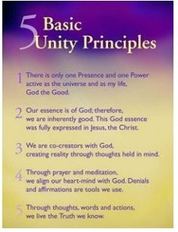
May Lessons: This month we continue to look at Unity’s 5 Principles from the perspective of various religious traditions and are delighted to have many Interfaith friends share with us. We are inspired by the book Unity and the World’s Religions by Rev. Paul Roach, Unity Minister.

5/7 “Unity & the Baha’i Faith” Guest Speaker Almitra Henderson
5/14 “Unity & The Divine Feminine” with Rev. Drak Druella
5/21 “Unity & The Tao” with Andy Quinones
5/28 “Remembering” with Jacqi Morrison

Closing Circle/ Prayer of Protection//Peace
The Light of God surrounds us. The Love of God enfolds us.
The Power of God protects us. The Presence of God watches over us. Wherever we are, God is. And All is Well.

We welcome our guest speakers this month.
Almitra Henderson is a life-long Baha’i and long-time friend of Unity.
Rev. Drakar Druella is a Science of Mind minister and chaplain, who brings music as well as New Thought and Interfaith Messages.
Andy Quinones is a member of Unity, a spiritual seeker & artist & Community Partner.
Jacqi Morrision is a 40+ year member of Unity, Board Co-President, Jan’s left brain and right arm and now left leg!
How Blessed We Are!

Music to Remind Us

May the Blessing of God Rest upon You
(Wings of Song 174)

May the blessing of God rest upon you,
May God’s peace abide with you,
May God’s presence illuminate your heart,
Now and forevermore.

Ancient Mother (Circle of Song 117)

Ancient Mother, I hear your calling
Ancient Mother, I hear your song.
Ancient Mother, I hear your laugher,
Ancient Mother, I taste your tears.

In the Garden (WOS 89)

I come to the garden alone, while the dew is still on the roses;
And the voice I hear, Falling on my ear, The Son of God discloses,

Refrain: And He walks with me,
and SHe talks with me,
And He tells me I am Her own,
And the joy we share as we tarry there,
None other has ever known.

He speaks and the sound of his voice Is so sweet the birds hush their singing, And the melody that she gave to me within my heart is ringing. Refrain:

I’d stay in the garden with Her Though the night around me be falling, But He bids me go; Through the voice of woe, His voice to me is calling. Refrain:

Thank You for your generosity!
Because of you, we can do our work! Check out our Facebook & Website www.UnityofPomona.org https://www.unityofpomona.org/about-us
Digital Donations are also accepted on our “Network for Good” DONATE BUTTON on our Sunday Lessons on my Jan Chase Facebook History & Timeline https://www.facebook.com/jan.chase.52
and on our UnityChurchofPomona Facebook Page www.facebook.com/Unity-Church-of-Pomona

Information
We are grateful for Robert Wilkiewicz and Andy Quinones our technical producers, for Jacqi Morrison and Darlene Hargrove our Worship Assistants, for Angela Robertson and Jennifer Derry for coordinating our meals and for all who support us in many ways!

Sunday Food & Fellowship after our Service: Our Sunday Potlucks are back. Feel free to join us for food after our service and to bring food to share. Thanks. Donations go for our paper supplies. Thanks.

We celebrate with all who have May Birthdays!
Compassionate Pomona theme for May: Health & Well-Being

DAILY WORD May 2023
5/7 /Free: I am one with the freeing, guiding force of God.
5/14 Blessings for Mothers: I bless all mothers with thoughts of gratitude.
5/21 Protection: As I practice the presence of God, I feel secure.
5/28 Comfort: Loving memories comfort me.

Unity focuses on one of our 12 powers each month. In May we focus on POWER, the ability to master, have dominion and control. The disciple is Philip who represents power over our thoughts and feelings. The corresponding color is purple and
the location is the root of the tongue.
Affirmation: I have the power to create my world.

2023: Opening to this Adventure Called LIFE
As we awaken to the truth of our being, we begin to realize that life is a great adventure, filled with experiences that can bring us great joy, when we bring curiosity, nonresistance, willingness, and acceptance into each situation. It dawns on us that we no longer need to fight life because Life is another name for God, and is always there blessing us and calling us into the growth our souls call us to learn. As I open to allow Spirit to guide me and as I look with spiritual eyes, I find my life is filled with marvelous miracles.
MAY 2023 CLASSES/ EVENTS

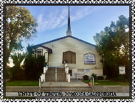
Our Sunday Lessons are live-streamed each week at 11 am PDT on Facebook through Jan Chase’s Time-Line and can be found and viewed later via her history. We are also gathering in person. Please join us in the way that works best for you. We hope you will share these timely lessons that help us understand ourselves, our needs, and others in this time of change. Please DONATE. Thank you for your tithes & gifts.

Mondays 5 – 6 pm: Book Study via Zoom with Jan Chase. Belonging to Life: The Journey of Awakening by Mary O’Malley. Zoom https://us02web.zoom.us/j/8282536942

Wed. 6:30 -7:30 pm Meditation/Prayer/Check-In on Zoom Meeting ID: 828 253 6942 (Join Zoom: https://us02web.zoom.us/j/828253694Unity2
One tap mobile: +16699009128,,8282536942# US
Dial by your location: +1 669 900 9128 US (San Jose)

Compassionate Pomona Meetings on Zoom The 1st Thursday at 9:45-11:30 am PST & 3rd Thursday at 10 am PST.To join the Zoom Meetings click or copy/paste this link: https://us02web.zoom.us/j/87534833472 ID: 875 3483 3472
Conversations with the Pomona Police: Tues.5/9/23 at 11 am.
Ask Renee Barbee reneebarbee7@gmail.com for zoom link or ID 89977661695 code: 539741.

Sun. May 21, 5-6:30 pm: Soul Connections on zoom:

Sun. May 21, 1:15- 3:30: Unity Board Meeting.

DATES FOR OTHER COMMUNITY EVENTS
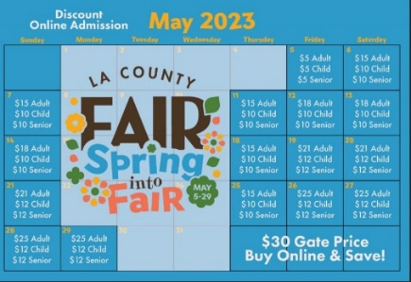

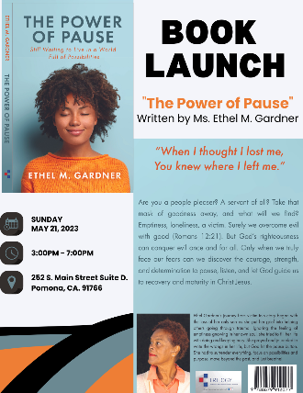

SERVING US AT UNITY OF POMONA
MINISTER: Rev. Jan Chase
BOARD MEMBERS: Jacqi Morrison & Phillip Senteno co-Presidents, Rev. Jan Chase, Jennifer Derry, Sharen Whitaker,
Advisory Board Members: Linda Lowry & Andrew Quinones
BUILDING & GROUNDS: Phillip Senteno, Jacqi Morrison, Andrew Quinones, Robert Wilkiewicz
COUNTERS: Sharen Whitaker, Treas.; Jacqi Morrison, Jan Chase.
FELLOWSHIP: , Angela Robertson, Sharen Whitaker, Robert Wilkiewicz, Jacqi Morrison, All of us!
FUNDRAISING: Our Board & Congregation & Robert Wilkiewicz
MARKETING & MULTIMEDIA: Jan Chase, Jennifer Derry, Andrew Quinones
OFFICE SUPPORT: Sharen Whitaker Office Manager, Jacqi Morrison, Linda Lowry, Jan
POWER POINT OPERATOR: Robert Wilkiewicz Andrew Quinones,
SANCTUARY PREPARATION: Jacqi Morrison, Jan Chase, Angela Robertson
SOUND SYSTEM: Jacqi Morrison, Robert Wilkiewicz
TECHNICAL SUPPORT: Andrew Quinones, Robert Wilkiewicz
WORSHIP ASSISTANT: Jacqi Morrison, Darlene Hargrove

UNITY OF POMONA
A “New Thought” Interfaith Community
Promoting Peace & Understanding through Spiritual Practices, Study & Service and the “Golden Rule” of all our Faiths.

.“Centered in God, We Co-Create A World that Works for All.”

Open & Affirming. Welcoming People of All Faiths
(Our sanctuary art is an expression of
the religious diversity welcomed here.)

Sunday Celebration Service: 11:00 am
Live-streamed and recorded on Jan Chase’s FB & saved on Unity of Pomona’s FB

Church Contact Information:
524 E. Pasadena St. Pomona, CA 91767

Rev. Jan Chase: Hm: 909-596-4187, Cell: 909-896-0991
Email: Janhoshin@aol.com

Website: https://www.unityofpomona.org/
Facebook: Unity Church of Pomona

Church Office Hours:
Friday Afternoons & by Appointment
Call Jan at 909-596-4187 to schedule Appointments

Silent Unity Prayer Line: 1-816-969-2000
& Prayer Email: unity.org/prayer

MAY 2023 AFFIRMATIONS
Inner Peace: Centered in God, I am secure and peaceful.
Wisdom: Within the silence of prayer, I gain a clear sense of direction.
Life: By the power of divine life, I thrive.
Prosperity: I welcome every blessing in a spirit of gratitude and generosity.
Faith: My eyes can see the beautiful potential within and all around me.

